Game Design Document

Fill up the following document

1. Write the title of your project.

The title of my project is online scrabble.

1. What is the goal of the game?

The goal of the game is to teach people how to make many words in a very short time with limited letters.

1. Write a brief story of your game.

So there is a little girl named rosy who has trouble making correct words. We have to help her do that by making some as an example for her to follow.

1. Which are the playing characters of this game?

* Playing characters are the ones who respond to the user based on the input from the user.
* Cars, monkeys, dinos, wizards, etc., are the playing characters in the game.

|  |  |  |
| --- | --- | --- |
| Number | Character Name | What can this character do? |
| 1 | Rosy | Can make word |

1. Which are the Non-Playing Characters of this game?

* Non-Playing characters are the ones that don't have an action or behavior when the user interacts with the game.
* Hurdles, stones, bananas, coins, etc., are non-playing characters in the game.

|  |  |  |
| --- | --- | --- |
| Number | Character Name | What can this character do? |
| 1 | The letters | It can make words |
| 2 | The board | It is like a mat |
| 3 | The holder | It holds the letters |

1. Draw your imagination of this game. What does this game look like?

* Draw the game either on your computer or on paper.
* Add images of the game scenes to show each of the playing and non-playing characters at least once.

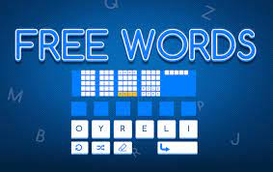

(Something Like This)

1. How do you plan to make your game engaging?

The game would have many levels and it would difficult as the level increases. There will be many powerups and scoring areas as well as a leaderboard to make it engaging. It will also have an option to buy hints with the coins you earn in the game to help you to make a word. You will also have a time limit to make as many words as you can and you will get 10 coins for 1 word. As the level increases the time limit will also decrease to make it much difficult.